Collet Clamp: inner threads: M7X1

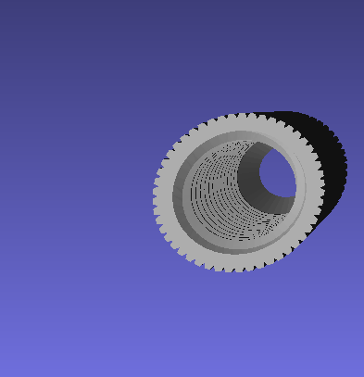

Handle M7 threads: outer threads: M7X1

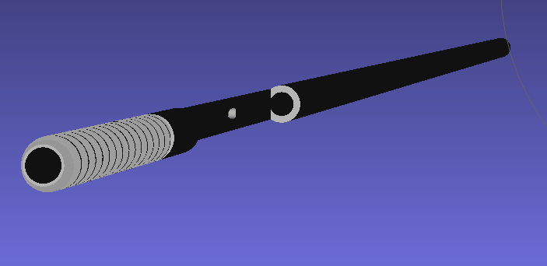

Wedge: inner thread: 4-40

